Story Problems

Patterning and Algebra
Unit 2 Line Master 2

1. In one week, Jess ran 4 times as
many laps of the track as Tyson. Jess ran 24 laps.
How many laps did Tyson run?

2. 35 students went on a field trip.  Three small buses were filled,  and 5 students travelled in cars.  How many students were in each bus? | 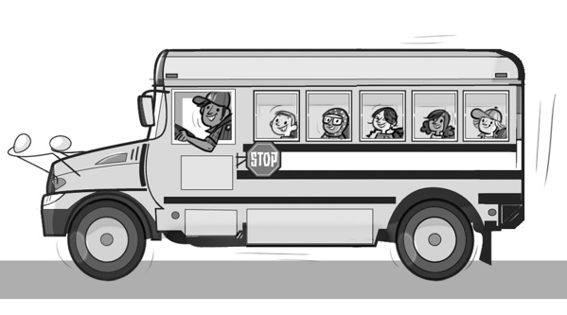

3. Ashton has $20 in their savings account.
They decide to deposit $5 per week, with a goal of saving $50.
After how many weeks will Ashton reach their goal?

