Rolling a Die and Relative Frequency

Data Management
Unit 1 Line Master 7a

Let’s use coding to explore the likelihood of rolling a 3
on a die.
Part 1
We’ll start by rolling a die in Scratch and checking to see
if a 3 is rolled.
- Click the link to access Scratch: Simple Dice Roll Completed:
https://scratch.mit.edu/projects/878484676/editor/
- Click the green flag to see what happens.
A die is rolled each time the green flag is clicked.
- Let’s alter the code to check if a 3 is rolled.
We will need to use a conditional structure.
Conditional structures are statements that tell computers to complete different actions based on different situations.
In Scratch, conditional structures, or if statements, are found in the Control tab. The if statement will check if a condition is true and if it is, it will execute the code after the word then. If the condition is not true, then nothing will happen.
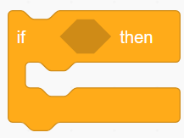

Rolling a Die and Relative Frequency

Data Management
Unit 1 Line Master 7b

- From the Control tab, select the if block and drag it below
the switch costume block:
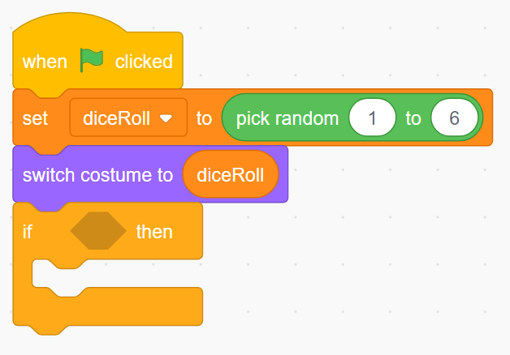
- Now we will add the condition for the if statement.
- From the Operators tab, select the equal comparison operator () and drag it inside of the conditional part of the if block.
- From the Variables tab, select the diceRoll variable, and place it inside the first part of the equal comparison operator.
- Type 3 in the second part of the equal comparison operator.
- From the Looks tab, select the say block and place it inside of the if block.
- Type 3! inside the say block.

Rolling a Die and Relative Frequency

Data Management
Unit 1 Line Master 7c

- Here is a screenshot of the completed code.
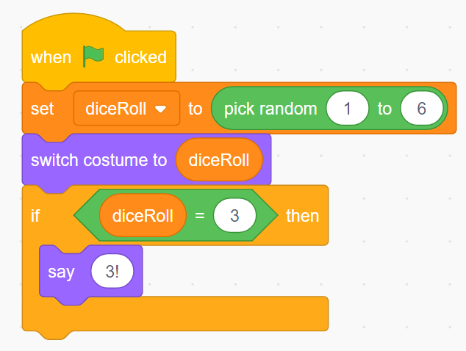

- Test the application by clicking the green flag many times.
Does it say “3!” each time the number three is rolled? If not, debug the application by carefully looking through the code.

Rolling a Die and Relative Frequency

Data Management
Unit 1 Line Master 7d

Part 2

Let’s use code to calculate the relative frequency of rolling a 3.

- We can calculate the likelihood of rolling a 3 using simple math:
There are 6 possible outcomes when rolling a die:
1, 2, 3, 4, 5, 6
So, the likelihood of rolling each of the numbers is 1 in 6, or $\frac{1}{6}$,
or about 0.17.

So, the likelihood of rolling a 3 is $\frac{1}{6}$.

- We can describe the likelihood of an outcome in an experiment using relative frequency.
Frequency can be a count of categorized observations or trials in an experiment. Relative frequency of outcomes can be used to estimate the likelihood of an event.

In our code, we will keep track of the number of times a 3 is rolled and the total number of rolls.

Each time we click the green flag to roll the die, we will calculate the relative frequency of rolling a 3.

Rolling a Die and Relative Frequency

Data Management
Unit 1 Line Master 7e

We will need three more variables in our application. We already have one variable called diceRoll, which holds the number that is rolled on the die.

We will create these additional variables:
- numRolls to keep track of the number of times the die is rolled, which is also the number of times the green flag is clicked.
- num3Rolled to keep track of the number of times a 3 is rolled.
- relativeFrequency to keep track of the relative frequency of rolling a 3.
Everything will be reset when we click the space bar.

Rolling a Die and Relative Frequency

Data Management
Unit 1 Line Master 7f

You can alter your code from Part A, as shown below,
or you can click the link to the completed code with which you can experiment.

Link to completed code:
https://scratch.mit.edu/projects/878489604/editor

Screenshot of code:
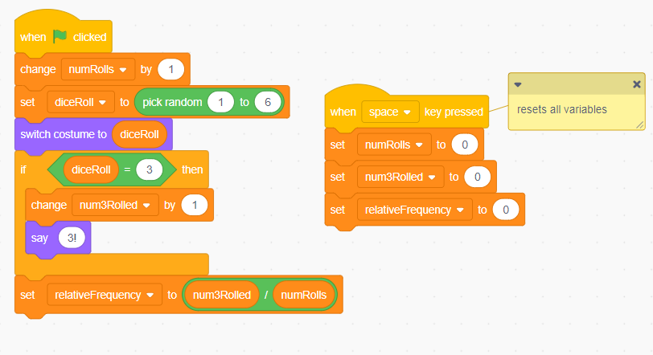

In Master 8, we’ll add a loop so we can simulate rolling a die hundreds, thousands, and even millions of times!

