Data Management
Unit 1 Line Master 9a

Statistics Game
Block Coding Program

Click the link to access Scratch: Dice Game – Doubles:
https://scratch.mit.edu/projects/484777128/
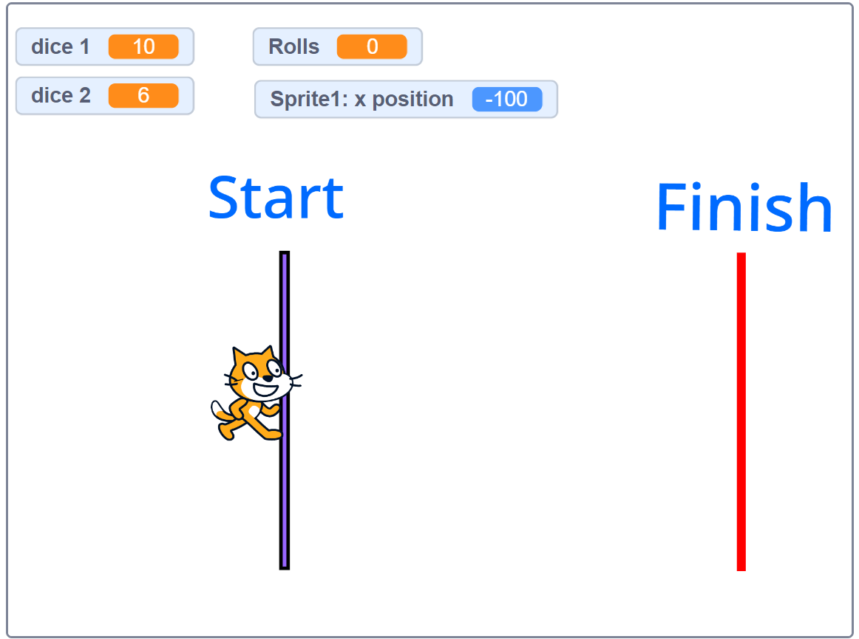

The starts the game, and the space bar rolls the dice.
Play until you win. Play again.
Compare your results with the class results when
students rolled number cubes.

Data Management
Unit 1 Line Master 9b

Statistics Game (cont’d)
Block Coding Program

Examine the Code
● Click See Inside. Look at the code.
What do you think the different blocks mean?
How do they relate to the statistics experiment?

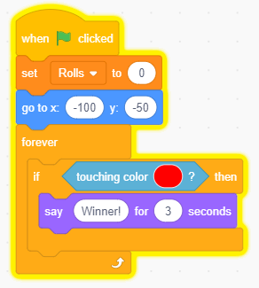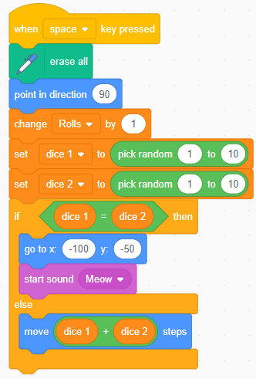

Data Management
Unit 1 Line Master 9c

Statistics Game (cont’d)
Block Coding Program

● Connect the blocks to what happened during the experiment.
For example,
has Cat facing right (looking from Start to Finish).
has Cat starting at (–100,50).
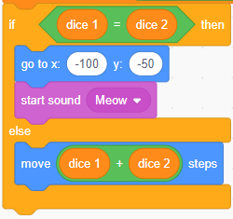 | has Cat go back to Start if  the dice match.
If the dice don’t match, the numbers
rolled are added.
Then Cat takes that many steps.
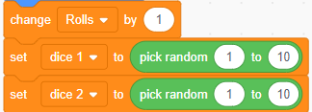 |  | has the roll tracked each time,  and random numbers are  chosen from 1 to 10.
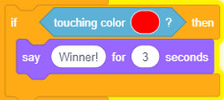 | has the Cat being declared  the Winner!  when the Cat touches the red  Finish Line.

Note:
Cat starts at –100 and ends up at 150.
Thinking about the distance on each side of 0,
100 pixels + 150 pixels = 250 pixels.

